Sales Ledger (Customer) AND

Purchase Ledger (Supplier) Accounts
Known as Contact Accounts in Xero

The API (Application Processing Interface) works by looking at the Agency Ref field
in Etz and matches this to a Contact Account Number in Xero.

The Mapping: (Etz) Agency Ref ID > (Xero) Contact ID

- It is important to ensure all Clients & Suppliers have the Agency Ref field populated in Etz. This will avoid issues later with Contact Accounts being created in Xero without a Contact Number.

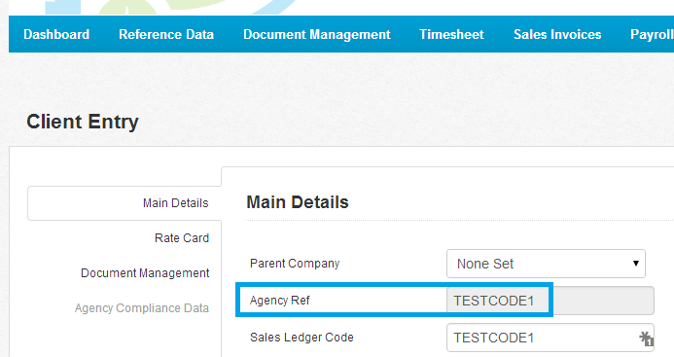

The Contact fields that will automatically update in Xero from Etz are;

- These can all be found in either the Client or Supplier Entry screens (Reference Data) in Etz

Client / Supplier Name
Client / Supplier Address
Client / Supplier Invoice Delivery Email (for multiple please use; as the separator)
Client / Supplier Vat Re Number

- If there is no Contact Account Number to match the Agency Reference then Xero will create a new Contact Account using the Agency Ref as the Contact Account Number for the new record.

Any transactions will then be posted to the new Contact Account in Xero automatically when the transactions are posted using the API.

If the matching of Account Numbers is exact via the mapping, i.e. Agency Ref in Etz is identical to the Contact Account Number in Xero; Then this is when Xero will automatically post the transactions to the mapped Accounts.

Etz – Client Entry

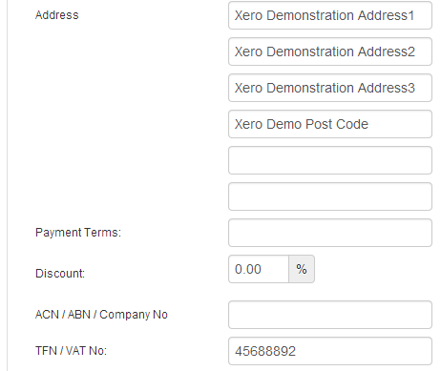

Xero – Contact

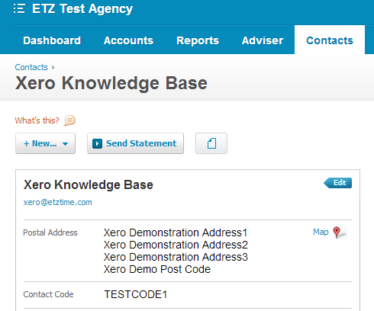
Xero – Contact > Financial Details

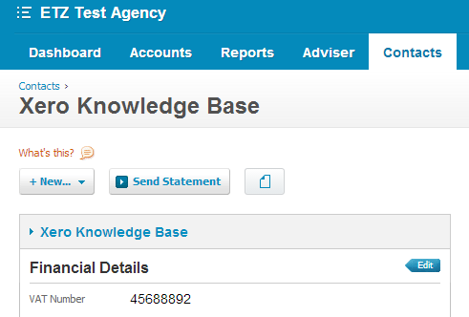

Any changes to the Client or Supplier record (using Client or Supplier Entry screens) in Etz will overwrite the Contact fields in Xero the next time the API is used.

