Sales LEDGER (Customer) AND

Purchase LEDGER (Supplier) INVOICES

The API (Application Programming Interface) works by looking at the Agency Ref field
in Etz and matches this to a Contact Account Number in Xero. For full details on how the mapping & Accounts syncronisation works please read this article;

Etz Clients/Suppliers mapped to Xero Contacts

- Credit notes raised in Etz are suffixed with CRN and are negative values. These values transfer to Xero as positives but are actually negative and Xero recognizes this by the CRN suffix.

Etz

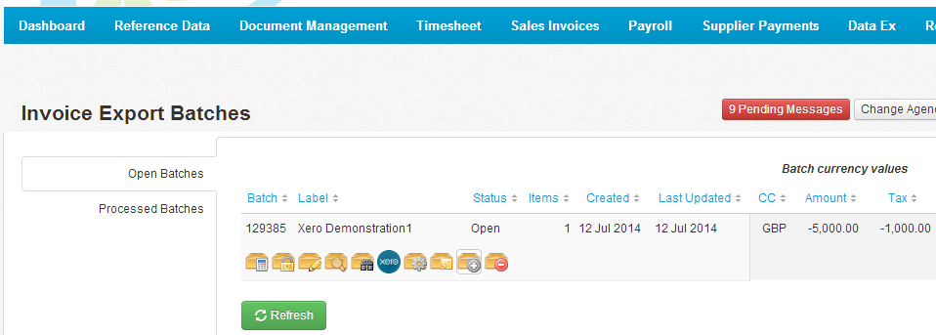

Xero

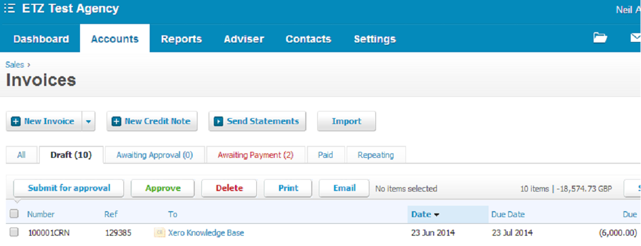

The Nominal Ledger Account codes can be added in three different places in Etz; Etz will take the first set of Nominal Codes in the following order.

Option1

- Assignment > Main > Accounting Interface (Bill Code, PayCode,Department Code)

When using this option Etz needs the codes to be input using a coma as the seperator, for example; 200, 325, 400

- This is how the codes have been input into Etz
.
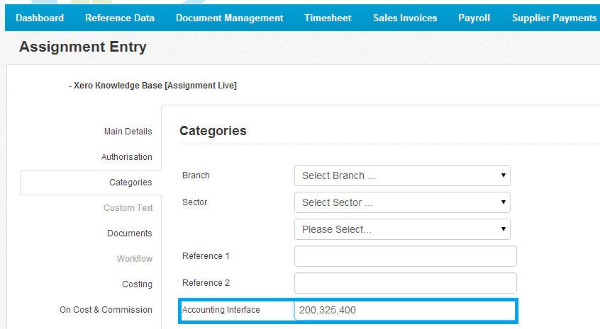

- This is how the codes have been posted at transactional level in Xero

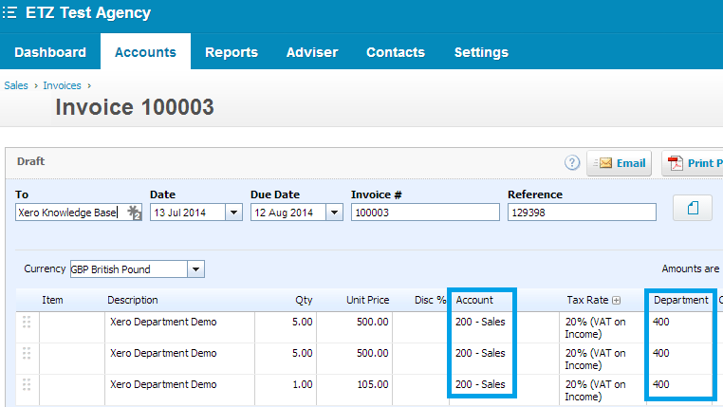

Option2

- Assignment > Sector (Bill Code/Pay Code)

Using this option means we need you to input the bill and pay codes using the separate code fields (Nominal Code for Pay & Nominal code for Bill) for each of the Sectors you set up.

Option3

- Rate Code > Nominal Code for Bill/Nominal Code for Pay

For more information on using either option2 or option3 please read the following article;
Where Do I Enter The Nominal Codes for Xero

- The Batch ID from Etz will populate in the Ref field held at the transaction level in Xero.
Etz

Xero batch/ref 129385

- Etz can process 3 levels of Analysis, known as Tracking Categories in Xero

The first requirement is to set up the Tracking categories in Xero, using Settings > General > Tracking Categories. It is only possible to create 2 Tracking Categories in Xero and due to this limitation Etz will only pass through the first 2 categories found. The Tracking Categories must be named Department/Consultant /Branch. The Tracking Categories need to be set up with the corrsponding Tracking Category information.

Xero

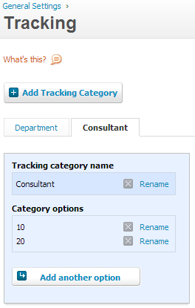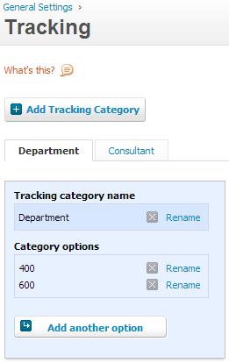

With the Tracking categories set up in Xero the same information needs to be input, in the following way, in Etz.

1st Tracking Category – Department

The 3rd CSV in the Accounting Interface field - in the example below – the Tracking Category Code is 400.

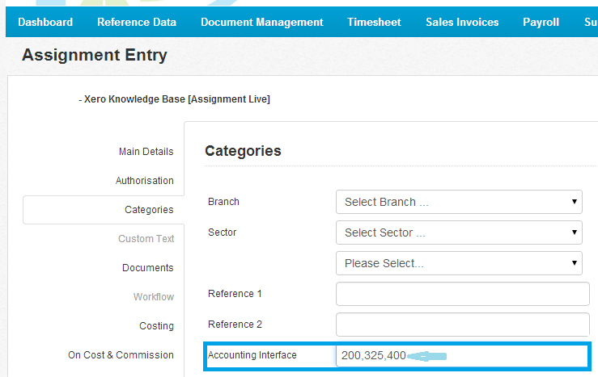

2nd Tracking Category Code – Consultant

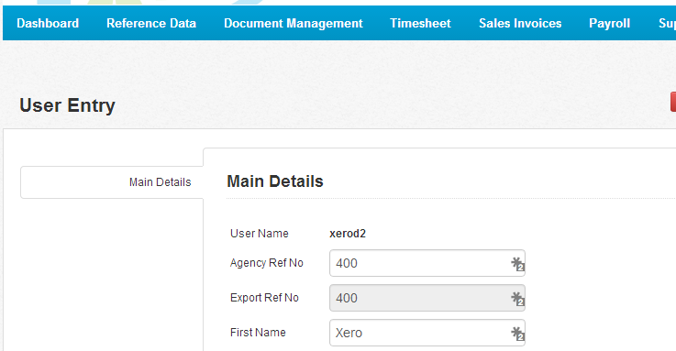

3rd Tracking Category Code – Branch

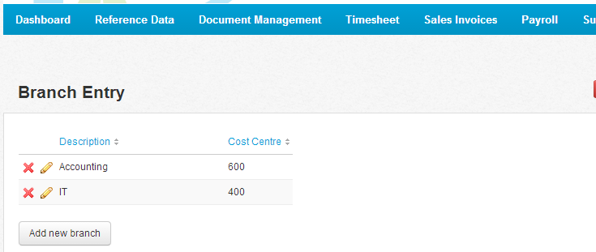

Etz and Xero are now ready for invoices and credit notes to be posted via the API

